# Module 2

**Assignment 2: Setting up a Lifecycle Policy in S3.**

**Example: For some security reasons, Setup 2 weeks (14 days) lifecycle for data to permanently delete it**

Below are the steps take to configure Lifecycle policy in s3.

1. Click on the bucket ‘**m2a1-bucket’**
2. Click on **Management**

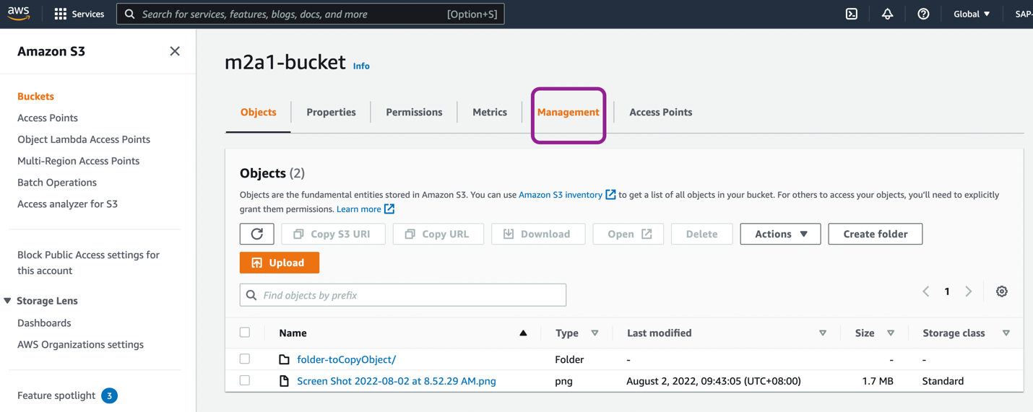

1. Click on ‘**Create lifecycle rule’**

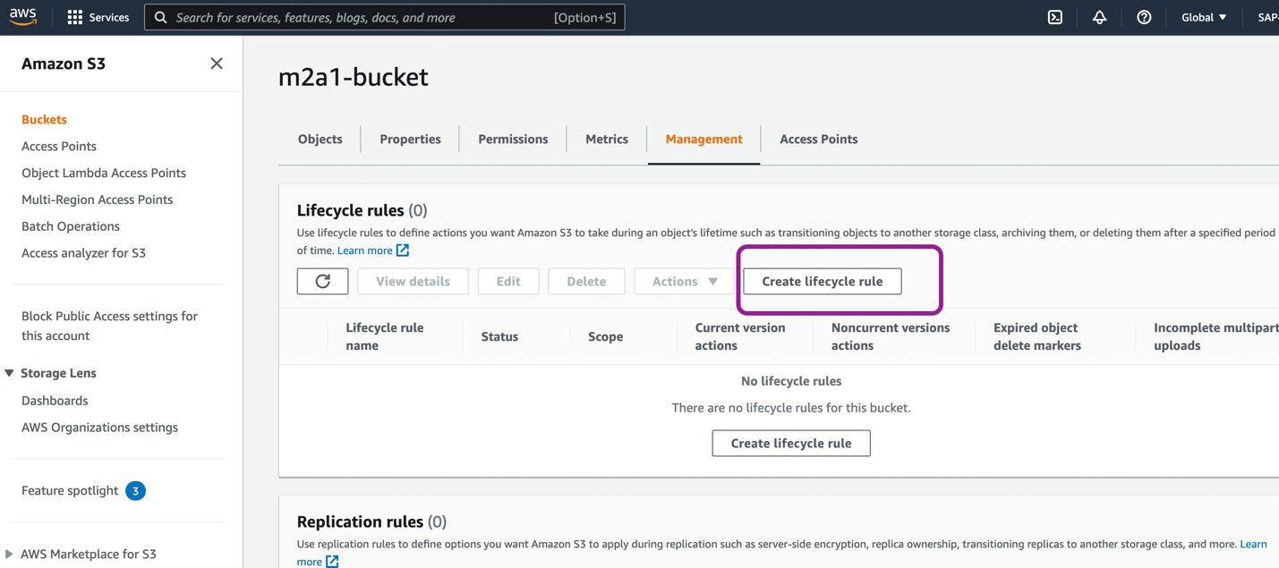

1. Give Lifecycle rule name – ‘**m2a1-bucket-lifecycle-rule1’**
2. Choose a rule Scope –
   1. **Limit the scope of this rule using one or more filters**: This option is selected by default, and I kept it as it is. Using this we can apply rule to selected objects.
   2. **Apply to all objects in the bucket**: Using this option all the objects will be bind with this rule.
3. **Prefix:** Here with proper prefix we can define the objects to apply rule.

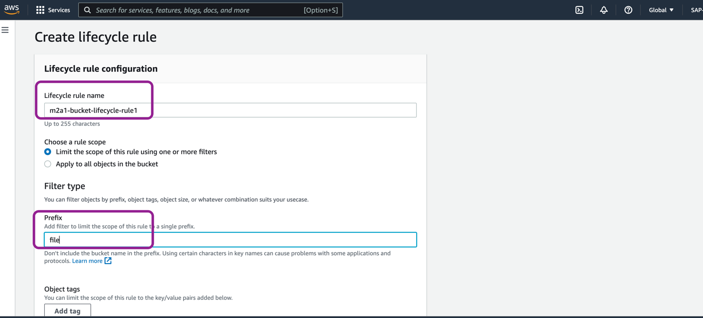

1. **Lifecycle rule actions**: In this section, actions can be configured on objects through the rule. I selected the **Expire current versions of objects** and **Delete expired objects delete marker or incomplete multipart upload**.

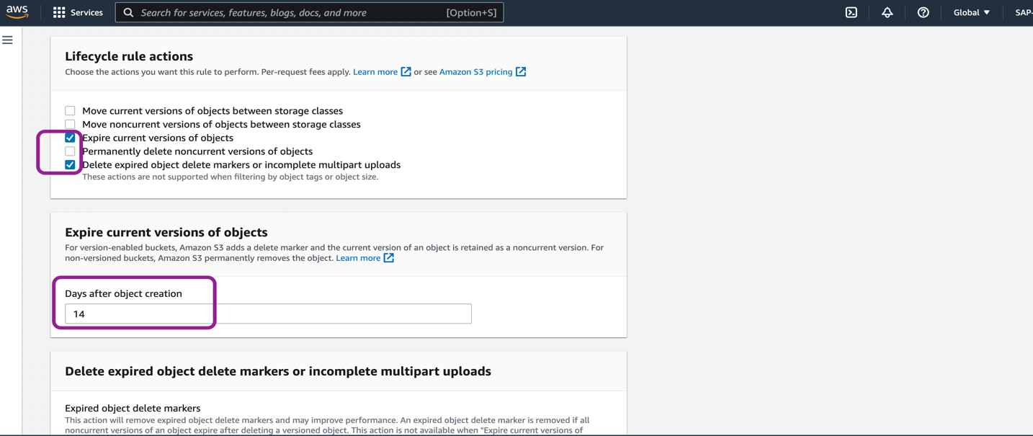

1. **Expire current versions of objects** - Put the number of days in it to expire the object, so that object will be eligible to delete. I put 14 days.
2. Click on ‘**Create rule’**

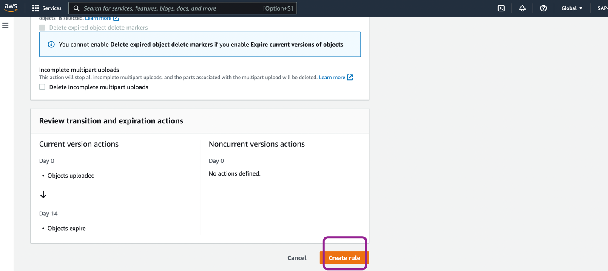

Now we can check the created rule under ‘Lifecycle configuration’ inside respective bucket.

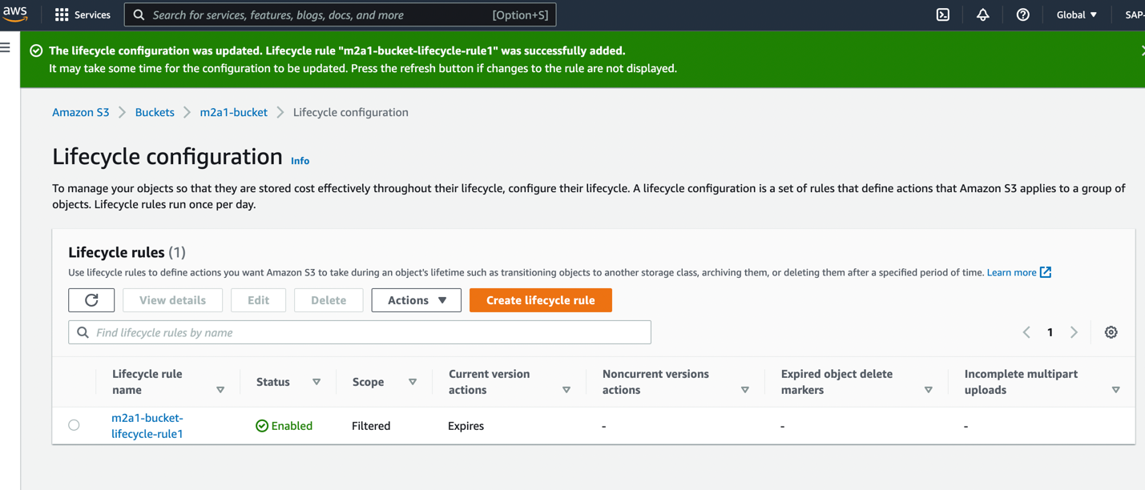

By clicking on rule, we can check and modify the configurations.

